Hawkeye Breeders Automatic Bill Payment
Automatic bill payment is available at Hawkeye Breeders. The electronic funds transfer payment plan is a convenient way to pay your bill. Simply authorize payment to Hawkeye and your bank will automatically withdraw your monthly payment from your checking or savings account. You save time, effort, and postage.
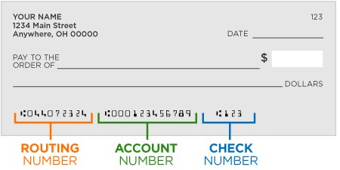
How does it work? On the 25th of each month (or the next banking day), we notify your bank or financial institution of the amount to be transferred from your account to pay your bill. The deduction will show up on your regular bank statement.
How do I sign up? Complete and sign the authorization form below and mail it, email it or drop it off. You will need to include a voided check or deposit slip as well. Mail to:
Hawkeye Breeders Service
32642 Old Portland Rd.
Adel, IA 50003 ph#515-993-4711 bjensen@hawkeyebreeders.com
Customer Name

Address
City | State |  | Zip Code
email |  | Telephone Number
I/We hereby authorize Hawkeye Breeders to initiate debit entries to my/our (select one of the following)
Checking

Savings

account in the financial institution (Bank) named below. I/We further authorize Bank to debit such entries to my/our account:
ABA Routing Number |  | Bank Account Number
Bank Telephone Number |  | Account Type – checking or savings
The total amount of bill due from the prior month will be deducted from your account unless other arrangements have been made with the Credit Manager at Hawkeye Breeders.

The authority will remain in effect until written notice from me (or either of us) of its termination in such time and in such manner to afford Hawkeye Breeders a reasonable opportunity to act on it. Customer assumes responsibility for erroneous information provided in the authorization. Further, I understand that Hawkeye Breeders may, at their discretion, void this agreement if sufficient funds are not available in my account to pay debit and that my account will be charged a $20 service fee for such transaction.

Authorized this Day of Year

Printed Name
Signature
Please allow 2 – 3 weeks for processing.

